10.11: a) 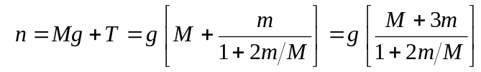

b) This is less than the total weight; the suspended mass is accelerating down, so the tension is less than mg. c) As long as the cable remains taut, the velocity of the mass does not affect the acceleration, and the tension and normal force are unchanged.

